Connection of autowatering system

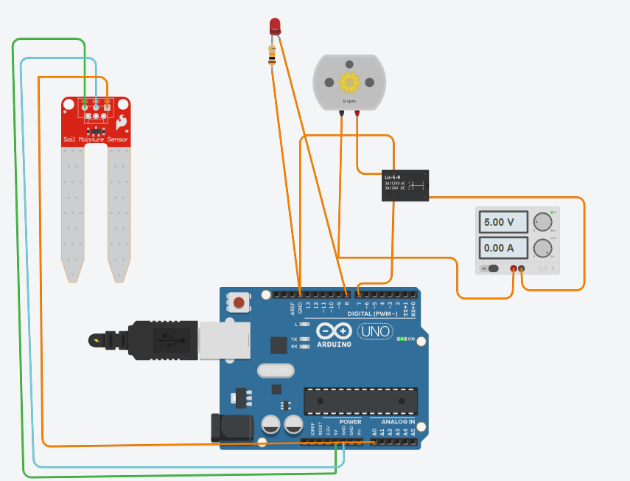

Code:

const int soilMoisturePin = A0;

const int ledDryPin = 8;

const int ledWetPin = 7;

void setup() {

pinMode(ledDryPin, OUTPUT);

pinMode(ledWetPin, OUTPUT);

Serial.begin(9600);

}

void loop() {

int soilValue = analogRead(soilMoisturePin);

Serial.print("Soil Moisture Value: ");

Serial.println(soilValue);

int threshold = 500;

if (soilValue < threshold) {

digitalWrite(ledDryPin, HIGH);

digitalWrite(ledWetPin, LOW);

} else {

digitalWrite(ledDryPin, LOW);

digitalWrite(ledWetPin, HIGH);

}

delay(1000);

}

Output:

